Modbus2SQL Server
V2.0alpha

Table of Contents
Licence 2
What Is Modbus2SQL 3
Modbus2SQL Advantages 3
Protocols 3
Dependancies 3
Support 3
Platforms 3
Installation 4
Mysql Installation - Windows 4
Mysql Installation – Linux (yum based) 4
ComPort RXTX System Specific Drivers 5
Windows 5
Mac OS X (x86 and ppc) 5
Linux (only x86, x86_64 5
Hardware 6
Limitations 6
Starting Modbus2SQL Server 7
Setting Up Modbus2SQL Server 8
Adding a Controller Type 8
Adding a Page of Modbus Data 9
What is a Page? 9
How do I create a Page of Data? 9
CSV Example 9
Inserting a Page of Data 9
Setting the Com Port 11

Licence

Copyright 2010 James A R Brown (james@enrogen.com), Enrogen Ltd

Licensed under the Apache License, Version 2.0 (the "License");
you may not use this file except in compliance with the License.
You may obtain a copy of the License at

http://www.apache.org/licenses/LICENSE-2.0

Unless required by applicable law or agreed to in writing, software
distributed under the License is distributed on an "AS IS" BASIS,
WITHOUT WARRANTIES OR CONDITIONS OF ANY KIND, either express or implied.
See the License for the specific language governing permissions and
limitations under the License.

What Is Modbus2SQL

Modbus2SQL is a Java Desktop Application that utilises a RS485 serial port to gather information from Modbus Slave devices and stores it in a MySQL Database.

It is designed as a backend server storing the data to SQL for use by a frontend system

Modbus2SQL Advantages

Where as you can access each Modbus device directly from your PC with suitable code, Modbus2SQL is constantly gathering the data from the Modbus device(s) and placing it all in a single database.

This means your frontend application has a single point of connection (utilising standard SQL commands and ethernet) once setup, no need to worry about serial ports, modbus instructions, modbus function codes and so on.

It also means multiple frontends can utilise and display the same data. Multiple frontends can query the database, where as in most cases Modbus only allows 1 master device per system.

The Modbus2SQL server can also be used independently as a Modbus testing system using the inbuilt viewer.

Protocols

The Modbus2SQL Server is configured as a Master Device with address = 1
The protocol is Modbus RTU.

Dependancies

Modbus2SQL Sever utilises the following Java Libraries

jamod - Modbus Java Class - Apache 2 Licence
opencsv - CSV Access Library - Apache 2 Licence
rxtx - Serial port access - LGPL v 2.1 + Linking Over Controlled Interface.

Without the work of the open source community this project would never have happened.

Support

This product has no official support. For commercial support please contact james@enrogen.com or www.enrogen.com for more contact info.

Platforms

Java is a multi platform environment, however as the application needs to access com ports it utilises some system native libraries supplied by the RXTX project.

Windows – Untested
Linux – X86_64 (Fedora 12) – Tested
Mac – Unknown

A suitable Java Runtime Environment JRE must be installed on your PC. www.java.com

Installation

Mysql Installation - Windows

For windows please download and install the binary at http://dev.mysql.com/downloads/mysql/
It is also recommended to download the workbench for database use.
http://dev.mysql.com/downloads/workbench/5.2.html

This manual assumes you will create a user and password with the standard settings
user : modbus2sql
pass : modicon

Once done you need to run the modbus2sql.sql script.

Mysql Installation – Linux (yum based)

In a console window

# yum install mysql
# yum install mysql-server
# yum install mysql-query-browser mysql-administrator
# /etc/init.d/mysqld start
# chkconfig –-level 345 mysqld on

You can then create a root user account on the server

# mysqladmin -u root password mypass
# mysqladmin -h hostname -u root password mypass -p

Now add a user for the Modbus2SQL Server

# /usr/bin/mysql
mysql > GRANT ALL PRIVILEGES ON *.* TO 'modbus2sql'@'localhost' IDENTIFIED BY 'modicon' WITH GRANT OPTION;
Query OK, 0 rows affected (0.06 sec)
mysql> flush privileges;
Query OK, 0 rows affected (0.04 sec)
mysql> create database modbus2sql;
Query OK, 1 row affected (0.00 sec)
mysql>exit
Bye
#

If using a remote server you need to also execute GRANT with '%' in place of 'localhost' to allow access to the SQL server from remote machines.

The default database connections used by Modbus2SQL (username etc) are defined in setting.xml which is created at first start. You can use the Modbus2SQL GUI to amend these to your liking and save to setting.xml

Now you can create the default tables included with this project (modbus2sql.sql is bundled)
# mysql -u root -p modbus2sql < modbus2sql.sql
Enter password:
#

ComPort RXTX System Specific Drivers

The RS485 utilises the serial driver originally from rxtx.qbang.org, but now supported as pre-compiled binaries from http://mfizz.com/oss/rxtx-for-java

Although this is a java application, it relies on some system specific drivers for Windows and Linux.

Please see the rxtx_drivers folder with this project. In each folder is an installer applicable to the platform.

Windows
rxtxSerial.dll goes in \jre\bin

Mac OS X (x86 and ppc)
there is an Installer with the RXTX source www.qbang.org
librxtxSerial.jnilib goes in /Library/Java/Extensions
Run fixperm.sh thats in the directory. Fix perms is in the Mac_OS_X
subdirectory.

Linux (only x86, x86_64
librxtxSerial.so goes in /jre/lib/[machine type] (i386 for instance)
Make sure the user is in group lock or uucp so lockfiles work.

For Fedora "yum install rxtx" installs the drivers automatically into /usr/lib/rxtx or /usr/lib64/rxtx as applicable.

You must install the drivers included with this package. There is NO need to install the RXTXComm.jar file to your java folder. It is already included with this package.

IMPORTANT
Linux - Ports MUST RWX by the user using the application.

Hardware

The following hardware has been tested successfully under Linux

EasySync USB to RS485 Interface
http://www.easysync-ltd.com/product/542/es-u-3001-m.html

The slave device used for the testing was a Deep Sea Electronics 8610 genset controller.

Limitations

The software currently only supports Modbus Function codes 3 and 16 (multiple read and write registers)

Starting Modbus2SQL Server

Run the java application by double clicking in windows, or for Linux issue the following command

# java -jar /path/modbus2sql.jar

The following should appear. As soon as the SQL server is live and the details correct the current SQL connection will flash green. Once the SQL connection is achieved the application will then attempt to startup the Modbus connection.

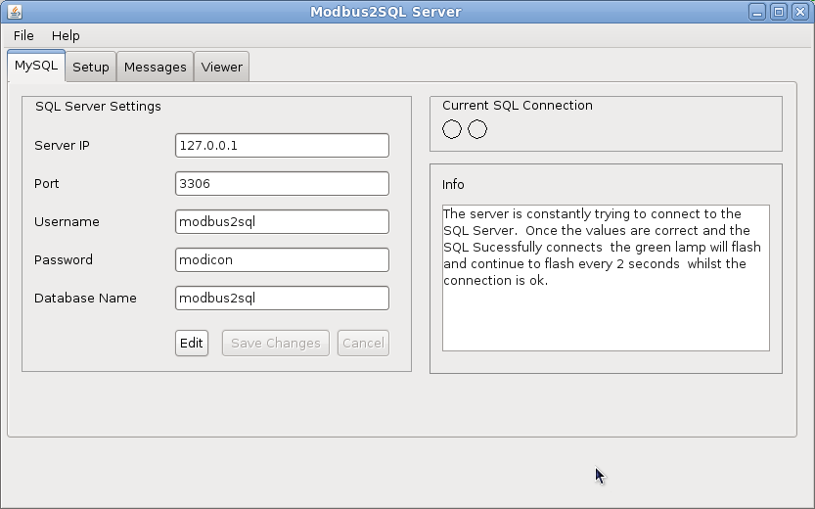

Setting Up Modbus2SQL Server

Adding a Controller Type

Select the Setup > Controller Types Tab and click the add button.

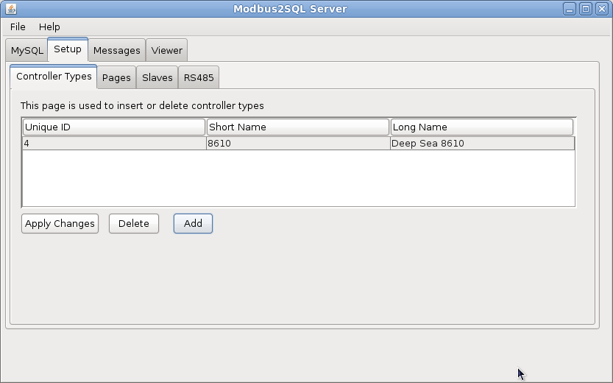
Now click the Add button

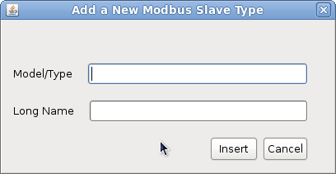
Give the controller a short name and a description. Click Insert to add it.

Adding a Page of Modbus Data

What is a Page?

A page is a block of modbus resgisters for each control. A block MUST

- Be consecutive Modbus Registers
- All registers in the page must be of a single Modbus Function Code.

How do I create a Page of Data?

Modbus2SQL utilises a CSV import facility to import predefined pages of data.

The CSV file containing the modbus page data must be in the format

A,B,C,D,E,F,G,H,I,END

Where
A | Register No | The Register No
B | Long Description | A long description
C | Minimum Value | The Minimum Value to be considered
D | Maximum Value | The Maximum Value to be considered
E | Scaling Factor | The scaling multipler that must be applied to the data
F | Units | A description for the units, such as KPA, DEG C
G | Bits | A choice of 16, 16S, 32,32S which are for Modbus  - 16 Bits (0 to 65535)  - 16 Bits Signed (-32768 to 32767)  - 32 Bits (0 to 4,294,967,295)  - 32 Bits Signed (-2,147,438,648 to 2,147,438,647)  The parser will work with 16 S as well as 16S
H | Low Byte Register | 32 bit data is stored in 2 x 16 byte registers referring to a high byte and a low byte. Eg  Low Byte High Byte  1111,1111,1111,1111|0000,0000,0000,0000  Result  1111,1111,1111,1111,0000,0000,0000,0000  So this value will store the “low byte” register number so the programme can combine in correct order and create the 32bit data.
I | Unimplemented Value | This value stores the “unimplemented” feature which is the value returned by the Device if it is polled for data it does not have access too.  For example some manufacturers will return 65535 if the request is not implemented in the firmware, or if the device is unable to find a value due to a sensor being out of range.
END |  | A convenience value that is ignored. It will help Excel or Openoffice Calc export the correct number of columns if empty to a CSV
There are some CSV included. If you develop a new CSV please email us and we will include with package.

CSV Example
1024,"Oil pressure",0,10000,1,"Kpa",0,0,65535
1025,"Coolant temperature",-50,200,1,"Degrees C","16 S",0,0,
1026,"Oil temperature",-50,200,1,"Degrees C","16 S",0,0,65535
1027,"Fuel level",0,130,1,"%",160,0,0,65535

Inserting a Page of Data

Select the Setup > Pages Tab

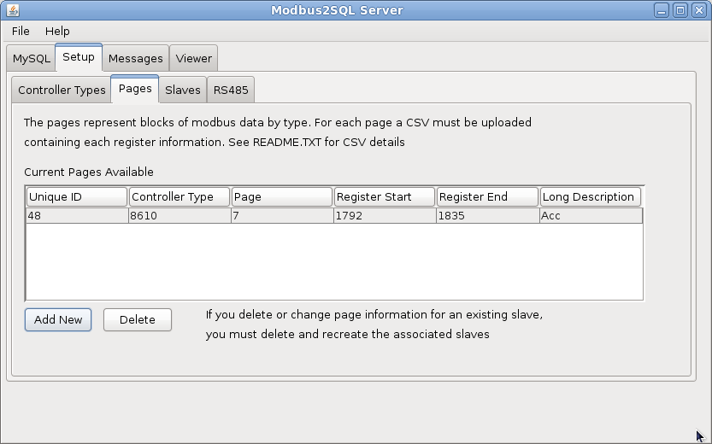

Now click the Add New Button. You can click the browse button to navigate to your csv file. Once done click the insert button.

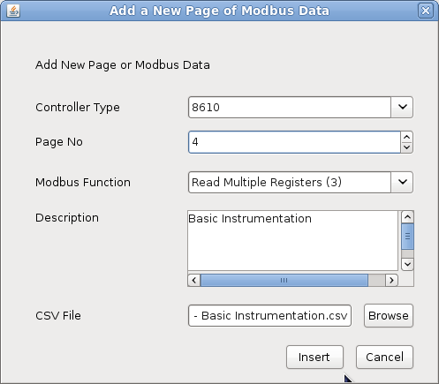

Inserting Slaves

At this point the application knows the controllers available and knows what registers it needs to read from those controllers.

Now all we need to do is tell is how many of each controller are available on the system and the applicable Modbus Slave ID.

Select setup > slaves tab.

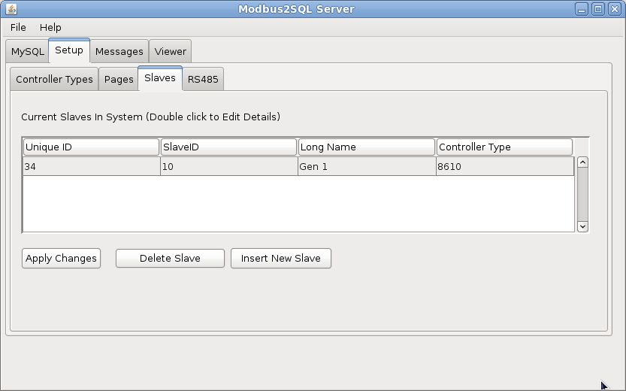

Now click Add Slave button

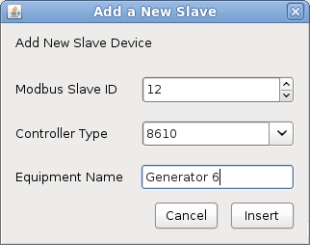

Setting the Com Port

The Com Port should be for RS485, 8 data, 2 stop bits and no parity. This is defined in the Modbus standards. To make any changes to the com port goto Setup > RS485. Clicking save will save the data to the SQL database.

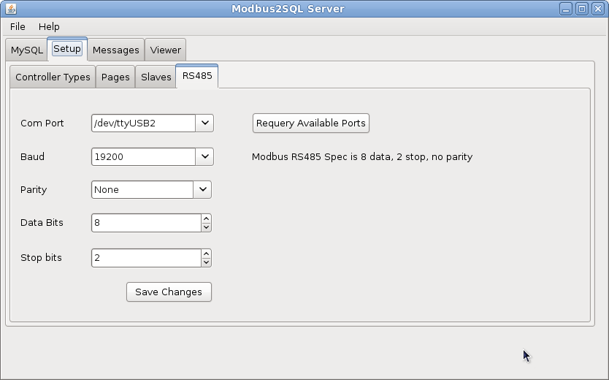

The Viewer

The Modbus2SQL server comes with a viewer. You can use this to check the data is all ok.

To view select the Viewer Tab. You can then select the slave you want from the drop down list. Once selected you can either click refresh to refresh once, or click “Auto Refresh” which will automatically refresh the data.

If you hover over a line on the table to get simple summary data.

As controls utilise 2 x 16bit Modbus registers to achieve 32bit data, the following should be noted :-

- The 16 bit binary string is always shown, this is the register valve
- The 16 bit integer is only shown when the value is 16 bit
- The 32 bit integer is only shown for HIGH BYTE registers of 32 bit data.
- The LOW BYTE half of a 32 bit register will display NULL.

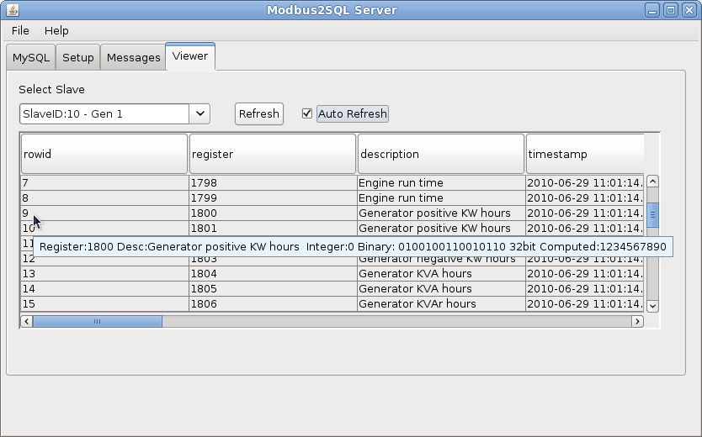

Utilising the SQL Database in your application

Getting A Register Value
To get a single register
Example Slave10
SELECT * FROM slave10;

Will return results for Slave with ModbusID 10, containing :-

Name | Type | Details
Rowid | Integer | Unique row no generated automatically by the SQL Server
Register | Integer | The Modbus Register No
Description | String | Description of the Register
TimeStamp | TimeStamp | The Timestamp the last time the 16binary conlumn was updated ie a successful read data from the slave
Livedata | Integer | Returns 1 = Data is Within 10 sec  Returns 0 = Data is older than 10 sec
16binary | String | The string representation of the data read for this register. This is the primary store of the modbus data. It is stored as a binary string to ensure at this point unsigned, signed and 32 bit integers do not need to be accounted for.
16integer | Integer | Computed Value based on :-  16Binary (Base2)  is32Bit = 0  isSigned  Will not be generated if register represents part of a 32 bit data
16hex | String | Hexadecimal Value :-  16Binary (Base2)  is32Bit = 0  isSigned  Will not be generated if register represents part of a 32 bit data
32binary | String | String representation based on :-  16binary  16binary of lowbyteregister  ie 16binary concat lowbyteregister 16binary = 32binary
32integer | Integer | Computed Value based on :-  32Binary (Base2)  is32Bit = 1  isSigned  lowbyteregister > 0  ie only fill the 32 integer column for 32bit data in the highbyte row.
32hex | String | Hexade Value based on :-  32Binary (Base2)  is32Bit = 1  isSigned  lowbyteregister > 0  ie only fill the 32 integer column for 32bit data in the highbyte row.
Is32bit | Integer | Returns 1 = 16bit data forms part of 32bit data  Returns 0 = is 16 bit data
IsSigned | Integer | Returns 1 = Most Significant Bit is used for signing (MSB value 0 = +ve, MSB value 1 = -ve),  Returns 0 = Value is unsigned (always +ve)
Changeflag | Integer | Always 0 for read
WriteData | Integer | Always 0 for read

Getting a Specific Register

This is done simply by adding a where clause to the SQL select command

SELECT * FROM slave10 WHERE register=1024;

Writing a Single Register (16 bit only)

This is done in 2 stages, firstly put the data in the table you want

UPDATE slave10 SET writedata=9876 WHERE register=1024;

To comit this

UPDATE slave10 SET changeflag=1 WHERE register=1024;

Or a single command can be used

UPDATE slave10 SET writedata=9786, changeflag=1 WHERE register=1024;

Writing Multiple Registers

Writing multiple registers MUST be done in 2 stages to ensure they are all written as a single block in a single Modbus command. It is important that the registers you are writing are in a consecutive block.

This facility is useful for writing 32 bit data, or 2 x 16 bit where the controller needs a value and a compliment value.

UPDATE slave6 SET writedata=35700 WHERE register=4104;
UPDATE slave6 SET writedata=29835 WHERE register=4105;
UPDATE slave6 SET changeflag=1 WHERE 4104 <= register AND register <= 4105;

This example is for a Deep Sea Electronics 55xx, 75xx or 86xx controller, place the control in STOP mode. (Deep Sea use a inverted bit compliment of the write data ie 65535 - writedata)

WatchDog Timer

The Modbus2SQL has an inbuild process thread that constantly monitors the timestamp against the SQL server time. When there is a difference in excess of 10sec the livedata column is set to 0 for the entire slave table.

You must utilise the livedata column in you project as a cross check to the information you are utilising.

Latency

It is clear the more devices you add with more registers, the slower the cycle will become. The following rules should apply

- Only create register blocks that you need if on a large system.
- Sort out bad connections, failed slaves with urgency. Where as a sucessful query is milliseconds in size, a failed attempt tries more than once with a 1 sec response waiting period.
- Ensure the server is not heavily loaded with other processes. This will delay the SQL transactions.

Alarms

Note : Ensure you have added the applicable standard modbus register blocks containing the alarms. The Alarm Monitor will monitor these registers for values you specifiy and then add to the log.

The log is 256 items.

